

Entertainer Biography

The Henry Armburg Jennings band features some of Europe’s finest jazz musicians. Collectively, the personnel have worked with the best musicians in the world including John Dankworth and Cleo Laine, Jools Holland, Van Morrison, Georgie Fame, Gilbert O’Sullivan and the National Youth Jazz Orchestra to name but a few ‘well- known’ artists! On the jazz small band scene, members from the band have worked with (again to name only a few!) the bands of Matt Wates, Jim Mullen and the Ronnie Scott’s House Band.

The band will work all over the country and usually provides two 45-60 minute sets. The band is perfectly suited to anything from background music to dancing music to an all out concert.

The ensemble is completely flexible in terms of line-up and selection/combination of instruments. Special requests are easily learnt and playing times are extremely flexible.

Entertainers Pictures
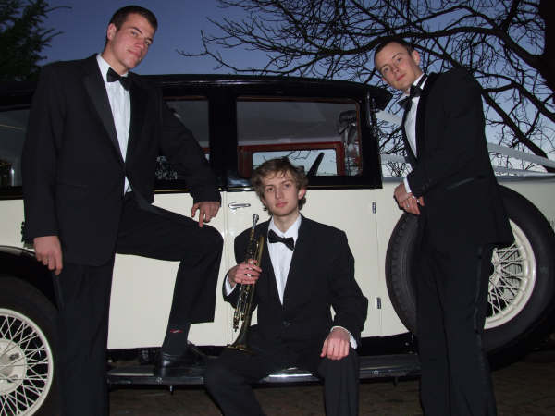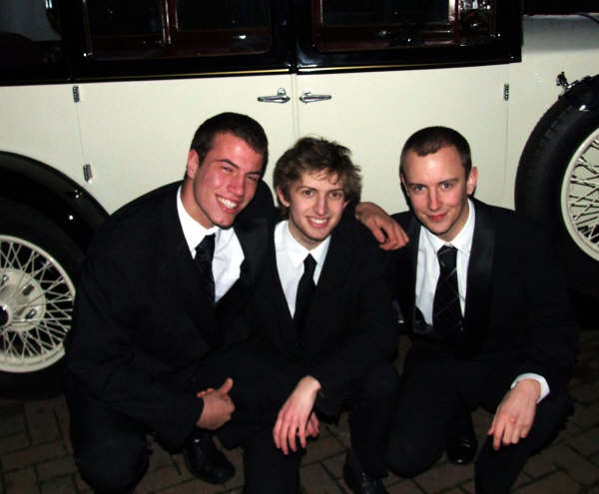

Sample Playlist

After You
After You’ve Gone
Afternoon In Paris
Ain’t Misbehavin’
Airegin
Alice In Wonderland
All Blues
All My Tomorrows
All Of Me
All Of You
All Or Nothing At All
All The Things You Are
All The Way
Almost Like Being In Love
Alone Together
Along Came Betty
Alright Okay You Win
Always And Forever
Amazing Grace
Angel Eyes
Anthropology
Anything Goes
A Time Goes By
At Long Last Love
Autumn Nocturne
Baltimore Oriole
A Beautiful Friendship
Begin The Beguine
Bess, You Is My Woman
The Best Is Yet To Come
Bewitched
Bidin’ My Time
Blue And Sentimental
Blue Gardenia
Blue Room
Blues In The Night
Bluesette
Born To be Blue
But Not For Me
Bye Bye Blackbird
Caravan
Close Enough For Love
Come Fly To Me
Cotton Tail
Crazy Rhythm
Cute
Dancing In The Dark
Dancing On The Ceiling
Darn That Dream
Days Of Wine And Roses
Dolphin Dance
Don’t Get Around Much Anymore
Doodlin’
Doxy
Dream Dancing
Dreamsville
Easy To Love
Embraceable You
Falling In Love With Love
Fascinating Rhythm
A Foggy Day
Four
Four Brothers
From This Moment On
Get Out Of Town
The Girl From Ipanema
Good Bait
Groovin’ High
Have You Met Miss Jones
He Was Too Good To Me
Honeysuckle Rose
Hot House
How Do You Keep The Music Playing
How Insensitive
How Little We Know
How Long Has This Been Going On
I Can’t Get Started
I Concentrate On You
I Could Write A Book
I Cover The Waterfront
I Didn’t Know About You
I Didn’t Know What Time It Was
I Get A Kick Out Of You
I Got Rhythm
I Had The Craziest Dream
I Love Paris
I Love You
I Loves You Porgy
I May Be Wrong
I Only Have Eyes For You
I Want To Be Happy
I Was Doing All Right
I Wish I Knew
I Wish I Were In Love Again
I’m A Fool To Want You
I’ve Got A Crush On You
I’ve Got You Under My Skin
If There Is Someone Lovelier Than You
In The Midnight Hour
Indian Summer
Invitation
Isn’t It A Pity
It Ain’t Necessarily So
It Had To Be You
It Never Entered My Mind
It Was A Very Good Year
It’s All Right With Me
It’s De-lovely
It’s You Or No One
Johnny One Note
Just One Of Those Things
The Lady Is A Tramp
Lester Leaps In
Let’s Call The Whole Thing Off
Let’s Do It
Li’l Darlin’
Like Someone In Love
Love For Sale
Love Is A Many Splendoured Thing
Love Me Or Leave Me
Love Walked In
Lover, Come Back To Me
Lucky To Be Me
Lullaby Of Broadway
The Man I Love
Miss Otis Regrets
Moondance
The More I See You
Mountain Greenery
Mr. Lucky
My Funny Valentine
My Heart Stood Still
Nancy (With The Laughing Face)
Nice Work If You Can Get It
Night And Day
Of Thee I Sing
Oh, Lady Be Good
The Old Country
Old Folks
On A Clear Day
On A Misty Night
Our Delight
Our Love Is Here To Stay
Please Don’t Talk About Me When I’m Gone
Put On A Happy Face
‘Round Midnight
‘S Wonderful
Secret Love
September In The Rain
Serenade In Blue
Shiny Stockings
Since I Fell For You
So In Love
Softly, As In A Morning Sunrise
Somebody Loves Me
Someone To Watch Over Me
A Song For You
Soon
Stormy Weather
Strike Up The Band
The Summer Knows
Summertime
Sunny
Sweet Georgia Brown
Take Five
Take The ‘A’ Train
Tea For Two
Teach Me Tonight
That Certain Feeling
There Will Never Be Another You
There’s A Small Hotel
These Foolish Things
They All Laughed
They Can’t Take That Away From Me
This Heart Of Mine
This Is Always
Thou Swell
Time After Time
Tokyo Blues
Too Marvellous For Words
Up Jumped Spring
Walkin’
What Am I Here For
What Is This Thing Called Love
When The World Was Young
When Your Lover Has Gone
Where Or When
Who Cares
Wichcraft
With A Song In My Heart
You And The Night And The Music
You Are Too Beautiful
You Do Something To Me
You Go To My Head
You Took Advantage Of Me
You’d Be So Nice To Come Home To
You’ll Never Know
You’re The Top

‘I’m a regular events organiser and you guys are the best band I’ve ever booked. I will definitely be booking you again in my next series!’ O. Rosenblatt – Jazz In The Lund series.

‘Just a quick note of thanks for last Saturday’s music at my party. It really gave it an air of sophistication and you were really easy to work with!’ – M. Mirza

"We booked Henry Armburg Jennings and his band after seeing them play. They were fantastic and really gave our wedding something extra. They were able to play all the old classics and give them a touch of modern flair. The atmosphere was captivating and many guests, if they weren't dancing, simply sat and lost themselves in the ambient sounds. My wife and I glowed with utter happiness romantic content. A great band. If you like Jazz then Henry and his band are a must!" Chad & Ruth - Wedding

‘Thanks for your help last Saturday, the music at the reception was wonderful and it was the perfect end to a perfect day. You’ll be our first call for all our anniversaries! – J. Sprinz

‘I would just like to say a big thank you for your playing last week, I did not speak to a single guest that didn’t enjoy it.’ – U. Read

